**Code**

1. public int test(int a, int b, int c){
2. int s;
3. boolean IsTriangle;
4. if ((a<b+c)&&(b<a+c)&&(c<a+b)){
5. IsTriangle = true;
6. }
7. else{
8. IsTriangle = false;
9. }
10. if (IsTriangle){
11. if((a==b)&&(b==c)){
12. s = 1;
13. }
14. else if((a!=b)&&(a!=c)&&(b==c)){
15. s = 3;
16. }
17. else{
18. s = 2;
19. }
20. }
21. else{
22. s = 4;
23. }
24. return s;
25. }

**Graph**

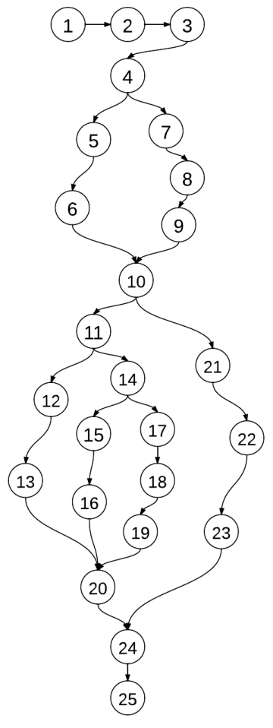 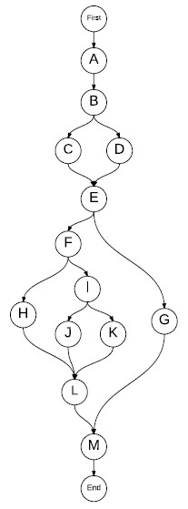

Program Graph DD-path Graph

**C1: Cover Every DD-Path**

**Model**

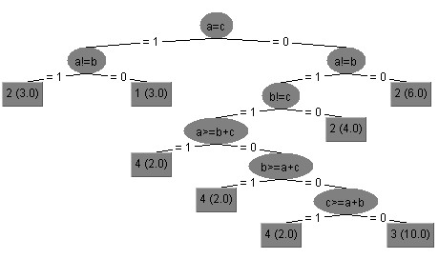

|  |  |  |  |  |  |
| --- | --- | --- | --- | --- | --- |
|  | | DD-Path Coverage | Input | Output(code) | Output(model) |
| 1 | P1 | First, A, B, C, E, F, H, L, M, End | 50, 50, 50 | Equilateral | Equilateral |
| P2 | First, A, B, C, E, F, I, J, L, M, End | 11, 23, 23 | Scalene | Isosceles |
| P3 | First, A, B, C, E, F, I, k, L, M, End |  |  |  |
| P4 | First, A, B, D, E, G, M, End |  |  |  |

**Decision Coverage**

**Model**

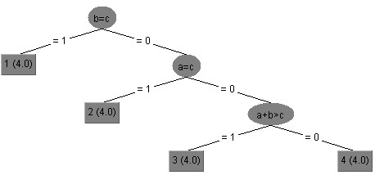

|  |  |  |  |  |  |  |  |  |
| --- | --- | --- | --- | --- | --- | --- | --- | --- |
|  | | Decision B | Decision E | Decision F | Decision I | Input | Output(code) | Output(model) |
| 1 | DC1 | True | True | True | / | 11, 11, 11 | Equilateral | Equilateral |
| DC2 | True | True | False | True | 10, 10, 5 | Scalene | Scalene |
| DC3 | True | True | False | False | 10, 8, 5 | Isosceles | Scalene |
| DC4 | False | False | / | / | 9, 9, 19 | Not a Triangle | Not a Triangle |

**Condition Coverage**

**Model**

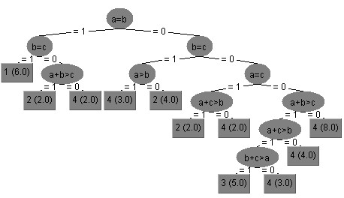

**Decision B**

|  |  |  |  |  |  |  |
| --- | --- | --- | --- | --- | --- | --- |
|  | | a < b + c | b < a + c | c < a + b | Input | Output |
| 1 | CC1 | True | True | False | 3, 4, 8 | Not a Triangle |
| CC2 | True | False | False | 2, 7, 2 | Not a Triangle |
| CC3 | False | True | True | 16, 5, 4 | Not a Triangle |

**Decision E**

|  |  |  |  |  |
| --- | --- | --- | --- | --- |
|  | | IsTriangle | Input | Output |
| 1 | CC1 | True | 3, 5, 4 | Scalene |
| CC2 | False | 6, 1, 7 | Not a Triangle |

**Decision F**

|  |  |  |  |  |  |
| --- | --- | --- | --- | --- | --- |
|  | | a == b | b == c | Input | Output |
| 1 | CC1 | True | True | 4, 4, 4 | Equilateral |
| CC2 | False | False | 16, 22, 30 | Scalene |

**Decision I**

|  |  |  |  |  |  |  |  |
| --- | --- | --- | --- | --- | --- | --- | --- |
|  | | a ==b | a !=c | b !=c | Input | Output(code) | Output(model) |
| 1 | CC1 | True | True | True | 7, 7, 16 | Not a Triangle | Not a Triangle |
| CC2 | True | False | False | 6, 6, 6 | Equilateral | Equilateral |
| CC3 | False | True | True | 11, 6, 8 | Isosceles | Scalene |

**Multi-Condition Coverage**

**Model**

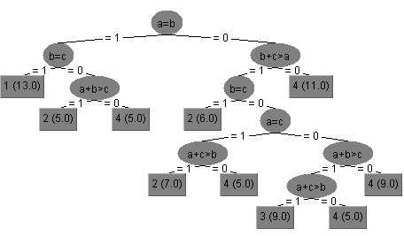

**Decision B**

|  |  |  |  |  |  |  |
| --- | --- | --- | --- | --- | --- | --- |
|  | | a < b + c | b < a + c | c < a + b | Input | Output |
| 1 | MCC1 | True | True | True | 3, 3, 3 | Equilateral |
| MCC2 | True | True | False | 3, 4, 8 | Not a Triangle |
| MCC3 | True | False | True | 2, 7, 2 | Not a Triangle |
| MCC4 | False | True | True | 9, 5, 4 | Not a Triangle |
| MCC5 | True | False | False | / | / |
| MCC6 | False | True | False | / | / |
| MCC7 | False | False | True | / | / |
| MCC8 | False | False | False | / | / |

**Decision E**

|  |  |  |  |  |
| --- | --- | --- | --- | --- |
|  | | IsTriangle | Input | Output |
| 1 | MCC1 | True | 6, 7, 8 | Scalene |
| MCC2 | False | 5, 8, 14 | Not a Triangle |

**Decision F**

|  |  |  |  |  |  |
| --- | --- | --- | --- | --- | --- |
|  | | a == b | b == c | Input | Output |
| 1 | MCC1 | True | True | 24, 24, 24 | Equilateral |
| MCC2 | True | False | 13, 13, 8 | Isosceles |
| MCC3 | False | True | 6, 4, 4 | Isosceles |
| MCC4 | False | False | 6, 4, 5 | Scalene |

**Decision I**

|  |  |  |  |  |  |  |  |
| --- | --- | --- | --- | --- | --- | --- | --- |
|  | | a ==b | a !=c | b !=c | Input | Output(code) | Output(model) |
| 1 | MCC1 | True | True | True | 15, 15, 27 | Scalene | Isosceles |
| MCC2 | True | True | False | / | / | / |
| MCC3 | True | False | True | / | / | / |
| MCC4 | False | True | True | 17, 26, 31 | Isosceles | Scalene |
| MCC5 | True | False | False | 3, 3, 3 | Equilateral | Equilateral |
| MCC6 | False | True | False | 2, 13, 13 | Isosceles | Isosceles |
| MCC7 | False | False | True | 6, 9, 6 | Isosceles | Isosceles |
| MCC8 | False | False | False | / | / | / |